材料科學系碩士班
國立臺南大學106學年度 招生考試 材料科學導論 試題卷

- Please (a) draw an illustration to indicate the coordination number (4%) and
(b) calculate the packing factor (6%) in the body-centered cubic (BCC) unit cell.

- The crystal shown in Figure 1 contains two dislocations A and B.
(a) Please indicate the Burgers vectors of A and B, respectively. (5%)
(b) If a shear stress τ is applied to the crystal as shown, what will happen to dislocations A and B? (5%)
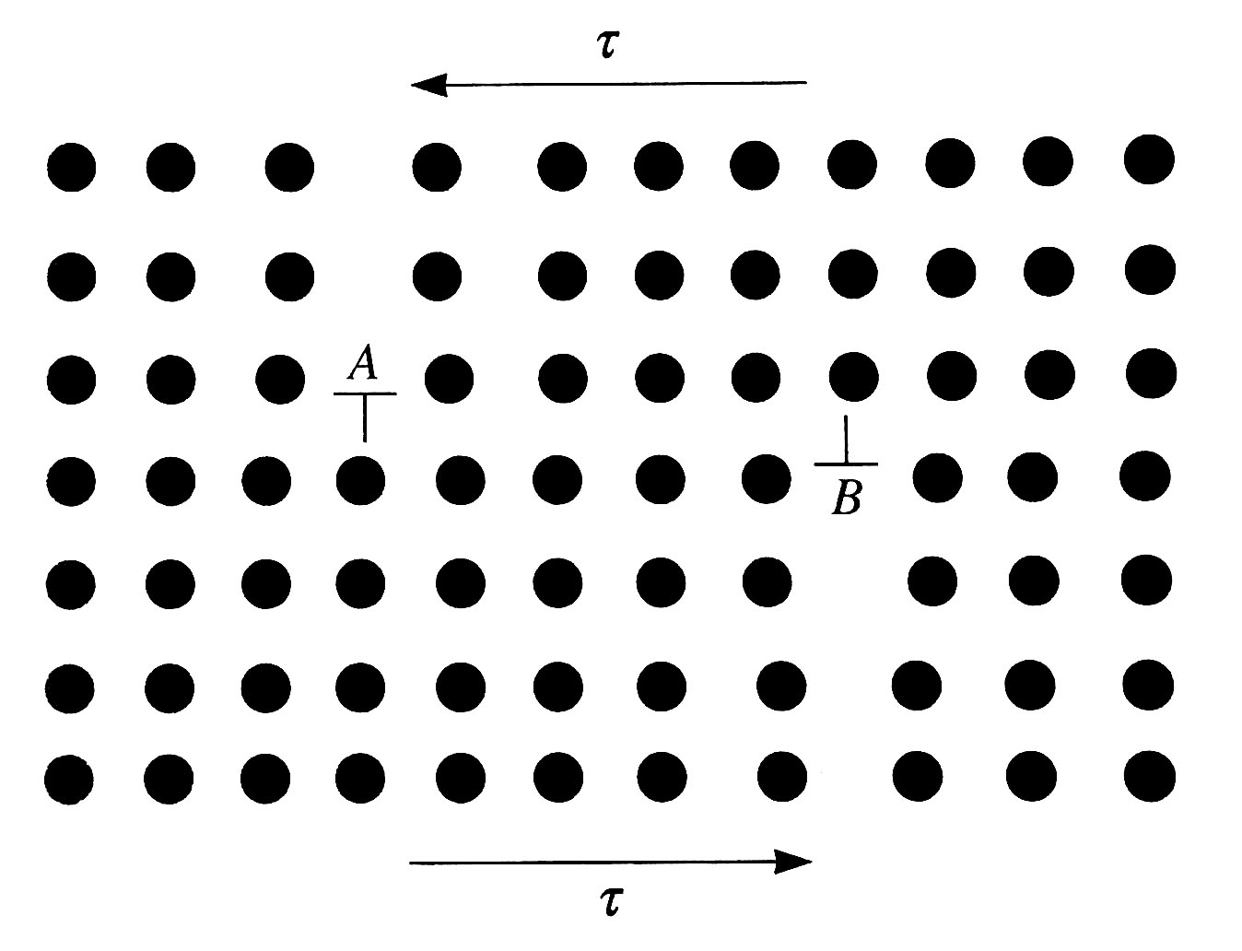
Figure 1. A schematic diagram of two dislocation in a crystal

- In the solidification of a metal,
(a) what is the difference between an embryo and a nucleus? (5%)
(b) What is the critical radius of a solidifying particle? (5%)

- (a) What is solid-solution strengthening? (5%)
(b) What are two important factors that affect solid-solution hardening? (5%)

- Please explain why the conductivity of pure metals decreases with increasing temperature, while the opposite is true for semiconductors and insulators. (10%)

- Draw (a) the [1 $\overline{3}$ 1] direction and (b) the ($\overline{3}10$) plane in a cubic unit cell. (10%)

- What are (a) the Hall-Petch equation, and (b) the Critical Resolved Shear Stress. (10%)

- Describe the microstructures with schematic diagrams at Region A, Region B and Region C in the Pb-Sn system at the composition indicated by the dash line. (10%)
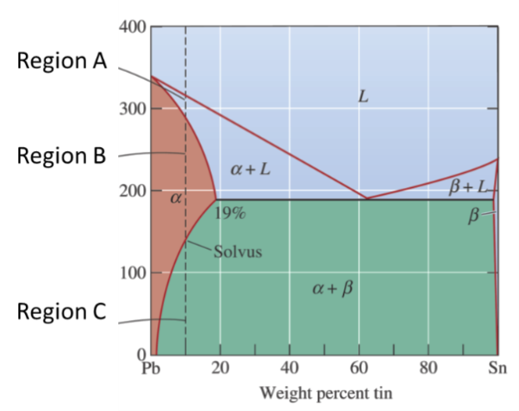

- (a) What are the three steps in the precipitation hardening heat treatment process. (b) What is the difference between “artificial aging” and “natural aging”? (10%)

- Describe
(a) the determination of the 0.2% offset yield strength in typical alloys, and
(b) the yield point phenomenon in low carbon steels. (respective stress-strain curves should be included) (10%)

